Incident Lifecycle Automation in ServiceNow
4. Project Planning Phase
4.1 Project Execution Roadmap
Project Name: Incident Lifecycle Automation in ServiceNow
The project is planned to automate and standardize the complete incident management lifecycle in ServiceNow. The project activities are divided into milestones covering service configuration, incident creation, classification, knowledge assistance, escalation, change management, resolution, and knowledge creation.
Milestone | Planned Activity
Milestone 1 | Create Service
Milestone 2 | Create Service Offering
Milestone 3 | Create Incident
Milestone 4 | Classify Incident
Milestone 5 | Integrate Knowledge
Milestone 6 | Update Watch List
Milestone 7 | Reassign Incident
Milestone 8 | Level 2 Investigation
Milestone 9 | Create Emergency Change
Milestone 10 | Create Child Incident
Milestone 11 | Add Cause
Milestone 12 | Add Resolution
Milestone 13 | Create Knowledge Article
Milestone 14 | Final Validation
Milestone 15 | Testing and Deployment

4.2 Task Planning
Phase A – Service Configuration
Objective: Configure the required service and service offering for the incident.
- Create Remote Access service.
- Set the operational status.
- Create Corporate VPN service offering.
- Associate the offering with Remote Access.
Deliverable: Remote Access service with Corporate VPN service offering.
Phase B – Incident Management
Objective: Create and classify a VPN-related incident.
- Impersonate Service Desk user.
- Create a VPN incident.
- Add caller and short description.
- Assign the incident to Service Desk.
- Update incident details.
- Select Network → VPN category.
- Set urgency and priority.
- Associate service, service offering, and CI.
Deliverable: Properly created and classified VPN incident.
Phase C – Knowledge Management
Objective: Use existing knowledge to assist in resolving the incident.
- Open Agent Assist.
- Search for relevant VPN Knowledge Articles.
- Open the appropriate article.
- Mark the article as Helpful.
- Attach the article to the incident.
- Add relevant comments.
Deliverable: Relevant Knowledge Article attached to the incident.
Phase D – Collaboration and Escalation
Objective: Collaborate with stakeholders and escalate the incident to the appropriate support team.
- Add stakeholder to the Watch List.
- Add user to the Work Notes List.
- Reassign the incident to Network Support.
- Verify the Assigned To field.
- Impersonate Level 2 Technician.
- Assign the incident to the technician.
- Verify incident and SLA information.
Deliverable: Incident successfully escalated to Level 2 support.
Phase E – Change and Child Incident Management
Objective: Manage additional work required to resolve the incident.
- Update the Configuration Item.
- Set the incident to On Hold.
- Select Awaiting Change.
- Create and link an Emergency Change.
- Create a Child Incident.
- Verify the parent-child relationship.
Deliverable: Emergency change and child incident linked to the parent incident.
Phase F – Resolution
Objective: Document the cause and resolution and complete the incident.
- Add the probable cause.
- Add the resolution code.
- Add resolution notes.
- Resolve the parent incident.
- Verify the child incident status.
- Verify the change request relationship.
Deliverable: Incident resolved with complete resolution information.
Phase G – Knowledge Creation
Objective: Create reusable knowledge based on the incident resolution.
- Select Create Knowledge.
- Select IT Knowledge Base.
- Select Standard template.
- Verify the article information.
- Save the Knowledge Article.
- Verify the article under Related Records.
Deliverable: New Knowledge Article created from the incident resolution.
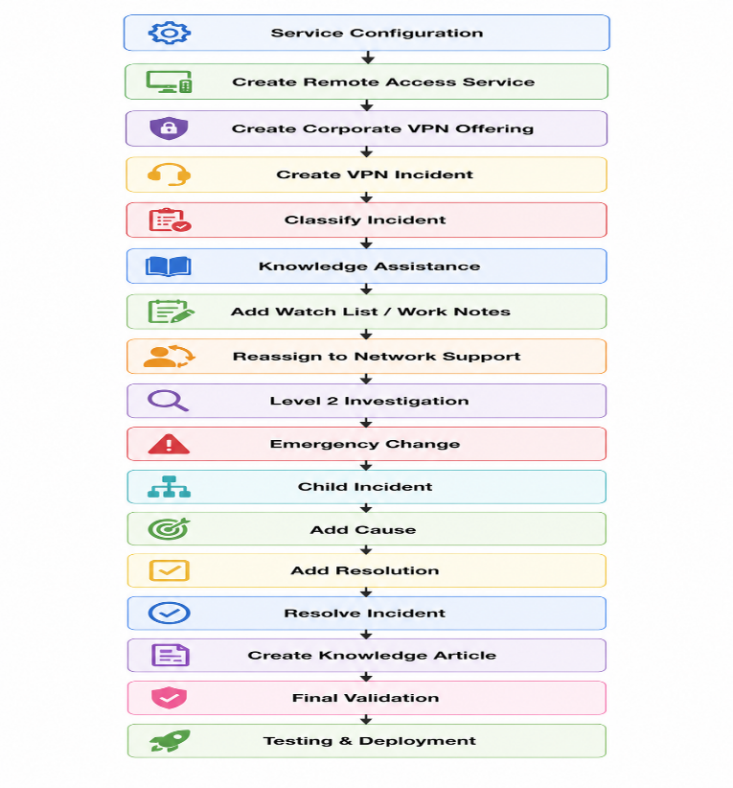
4.3 Project Workflow

4.4 Project Deliverables
Phase | Deliverable
Service Configuration | Remote Access Service and Corporate VPN Offering
Incident Management | Created and classified VPN Incident
Knowledge Management | Knowledge Article attached to Incident
Collaboration & Escalation | Incident assigned to Level 2 Network Support
Change Management | Emergency Change linked to Incident
Child Incident Management | Parent-Child Incident relationship
Resolution | Cause and Resolution details
Knowledge Creation | New IT Knowledge Article
Final Phase | Validated and tested project
4.5 Expected Project Outcome
At the end of the project, the Incident Lifecycle Automation in ServiceNow will demonstrate the complete incident management process from service configuration and incident creation to classification, knowledge assistance, escalation, change management, resolution, and knowledge creation. This ensures that incidents are handled in a structured and traceable manner.

